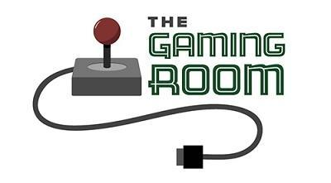

Draw It or Lose It

CS 230 Project Software Design Template
Version 1.0

Table of Contents

CS 230 Project Software Design Template 1
Table of Contents 2
Document Revision History 2
Executive Summary 3
Requirements 3
Design Constraints 3
System Architecture View 3
Domain Model 3
Evaluation 4
Recommendations 5

Document Revision History

Version | Date | Author | Comments
1.0 | 05/24/26 | Tyler Gyiraszin-Lada | Initial software design document

Executive Summary
The Gaming Room is a company that created the game Draw It or Lose It for Android devices. The company now wants to expand the game so it can run across multiple platforms including Windows, Mac, Linux and web browsers. To support this goal, a software design plan was created to evaluate different operating systems and determine the best solution for the company.
The main goal of this project was to design an application that is organized, scalable and easy to maintain. The program uses object-oriented programming concepts along with the singleton design pattern to manage games, teams and players efficiently. The design also focuses on portability, performance and security so the application can support future growth.
This document explains the system design, reviews different platform options and provides recommendations for the best overall solution for The Gaming Room.

Requirements
The Gaming Room wants to expand Draw It or Lose It from an Android-only game into a web-based application that can support multiple operating systems and devices. The application must allow multiple teams and players while ensuring each game, team and player has a unique name. The software also needs to maintain only one active instance of the game service at a time through the singleton design pattern.
The system should be scalable, secure and easy to maintain as the company grows. The application must also support distributed environments and reliable communication between platforms. Java was selected because it allows the application to remain portable across multiple operating systems while supporting object-oriented programming practices.

Design Constraints
One important design constraint is making sure only one instance of the game service exists while the application is running. This is handled using the singleton design pattern. Another requirement is preventing duplicate names for games, teams and players so the system stays organized and consistent.
The application also needs to support multiple operating systems and potentially large numbers of users in the future. Because of this, the design must remain flexible, scalable and platform independent. Security and performance are also important factors since the application may eventually support online multiplayer features.
Java was chosen for development because it works well across different operating systems and supports strong object-oriented programming practices. This makes the application easier to maintain and update over time.

System Architecture View

Please note: There is nothing required here for these projects, but this section serves as a reminder that describing the system and subsystem architecture present in the application, including physical components or tiers, may be required for other projects. A logical topology of the communication and storage aspects is also necessary to understand the overall architecture and should be provided.

Domain Model
The domain model for the application follows object-oriented programming principles. The Entity class acts as the parent class for the Game, Team and Player classes. This helps reduce duplicated code by allowing shared attributes like IDs and names to be inherited by the other classes.
The Game class stores information about each game and contains a list of teams. The Team class stores a list of players while the Player class represents individual participants. The GameService class is responsible for managing all game data and making sure duplicate names are not created.
The singleton design pattern is used in the GameService class to ensure only one instance of the service exists during program execution. This improves consistency throughout the application and helps avoid data conflicts.

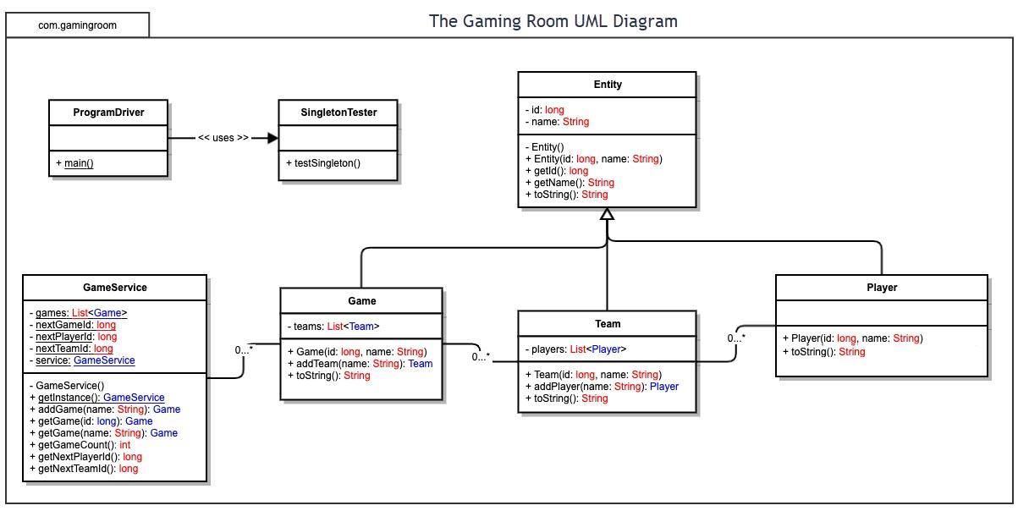

Evaluation

Windows
Windows is one of the most widely used operating systems and supports a large variety of software and development tools. It is user friendly and commonly used for gaming applications. However, Windows systems typically require more resources and licensing costs than other platforms.

Mac
Mac systems are known for their stability, security and performance. They are commonly used for software development and creative applications. The main disadvantages are higher hardware costs and fewer server deployment options compared to Linux.

Linux
Linux provides strong performance, security and customization options. Since it is open source, it can significantly reduce costs for companies. Linux is widely used for web servers and large-scale applications because of its reliability and scalability. The primary disadvantage is that it may require more technical knowledge to configure and maintain.
Development Requirements | Mac | Linux | Windows | Mobile Devices
Server Side | Mac servers provide stable performance and strong security features. They can host web applications but require Apple hardware, which increases costs. Licensing costs are generally low, but hardware expenses are higher than other options. | Linux is highly reliable, secure and cost effective for hosting web applications. It supports server-based deployment and scales well to thousands of users. Most Linux distributions are open source, resulting in little to no licensing costs. | Windows Server provides strong support for web applications and enterprise environments. It is user friendly and offers server deployment options, but licensing and maintenance costs are typically higher than Linux. | Mobile devices are not designed to host large web applications. Limited hardware resources and battery constraints make them unsuitable as server platforms.
Client Side | Mac users can access the application through modern web browsers. Development requires testing to ensure compatibility with Safari and other supported browsers. | Linux users can access the application through web browsers such as Firefox and Chrome. Additional testing may be required because of the variety of Linux distributions available. | Windows users can access the application through common web browsers including Chrome, Edge and Firefox. Windows provides broad compatibility for web applications. | Mobile users on Android and iOS can access the application through responsive web browsers. Developers must account for different screen sizes, touch controls and device performance.
Development Tools | Mac development commonly uses Java, Eclipse, IntelliJ IDEA and Visual Studio Code. Most of these tools are free or offer free versions. | Linux supports Java development tools such as Eclipse, VS Code and Git. Most development tools are open source and have little to no licensing costs. | Windows supports Eclipse, VS Code, Java SDK tools and GitHub. Some enterprise tools may require licenses, but most core development tools are available for free. | Mobile development may require Android Studio for Android devices and Xcode for iOS devices. Supporting multiple mobile platforms increases development and testing requirements.

Recommendations

Analyze the characteristics of and techniques specific to various systems architectures and make a recommendation to The Gaming Room. Specifically, address the following:

- Operating Platform: Linux is the recommended server platform for Draw It or Lose It. Linux is reliable, scalable and cost effective because it is open source. It supports Java applications and can run efficiently in cloud and distributed environments. Linux also provides strong security features and can support a growing number of users as the game expands to additional platforms.

- Operating Systems Architectures: Linux uses a layered operating system architecture with a kernel that manages hardware resources and system services. The operating system supports multiuser and multitasking capabilities, allowing multiple game sessions and users to operate simultaneously. Its client-server architecture makes it well suited for hosting Draw It or Lose It across different operating systems and devices. hosting. It also supports Java applications well through the Java Virtual Machine.

- Storage Management: Linux uses the Ext4 file system to organize and manage data efficiently. The file system provides reliable file storage, fast access times and recovery capabilities. For Draw It or Lose It, player accounts, game sessions and application data can be stored securely while maintaining consistent performance as the number of users grows.

- Memory Management: Linux uses virtual memory, paging and memory protection techniques to manage system resources. Virtual memory allows applications to use more memory than what is physically installed, while paging transfers inactive data between RAM and storage when needed. These techniques help maintain system stability and performance while supporting multiple users and game sessions.

- Distributed Systems and Networks: Draw It or Lose It should use a client-server architecture connected through TCP/IP networking protocols. The server manages player accounts, game data and communication between connected devices. This approach allows users on different operating systems to participate in the same game session. Network redundancy and reliable connectivity should be considered to reduce downtime and improve availability.

- Security: Linux provides strong security through user authentication, file permissions and access controls. Data transmitted between clients and the server should be protected using TLS encryption. Firewalls, software updates and secure password policies should also be implemented to protect user information and reduce security risks across multiple platforms.

